DRFT

Objectification of drift quality evaluation using AI

# The team

We are 3 friends from the student research group FiberTeam, located in Warsaw University of Technology, with members mostly from Faculty of Electronics and Information Technology. Being undergraduate students, we are eager to find new opportunities and challenges across many aspects of science and technology. Decision about the Imagine Cup was rather rapid, as the project started not more than a month ago, resulting in extremely intense period of time.

**Piotr Araszkiewicz** Warsaw University of Technology, Telecommunications, 2021 - Currently based in Warsaw (before in Lublin), originator of the project, vice chair for technical affairs in FiberTeam. Passionate about new solutions, started studying Telecommunications at Warsaw University of Technology in 2017, and began voluntary research work in 2018. Co-founder of FiberTeam, passionate about drifting and motorization.

**Jakub Kasperek** Warsaw University of Technology, Computer Science, 2021 - Based in Warsaw, fanatic of anything IoT related. Started studying Computer Science at Faculty of Electronics and Information Technology in 2017, joined FiberTeam in 2019 and quickly began the guru of anything concerning Arduino, sensors and technology. Dog lover and freelance software developer.

**Ernest Pokropek** Warsaw University of Technology, Computer Science, 2021 - based in Grodzisk Mazowiecki, project coordinator, vice chair for financial affairs in FiberTeam, aspiring data scientist and researcher while being undergraduate student. Interested in artificial intelligence, music and philosophy. Started studying Computer Science at Faculty of Electronics and Information Technology in 2017, and began voluntary research work in 2018, along with Piotr Araszkiewicz. Co-founder of FiberTeam, freelance software developer. Fanatic of good coffee and lover of martial arts.

# The Concept

Drifting is becoming more and more popular nowadays, however its judging system is still really subjective, one could even say behind the times, concerning the progress of the motorsport itself, as the score output relies on observations of humans, which we all know, can make mistakes.

To some extent, the most objective way of describing the surrounding us world, are sensors. Our idea was to put accelerometers and gyroscopes on the front and back of the car, and using metrics obtained from them, AI algorithm should classify whether the good quality slip is happening, by analyzing the centripetal forces ratio over the sensor groups. Briefly speaking, different values of acceleration and forces impacting the front and rear sensor groups, can indicate that the vehicle is over or understeering.

First, by assembling the numerical (mathematical) model, being able to label the perfect data, first AI models are to be trained. Then, those models are tested on the real-world data, whether they detect the drift correctly.

Besides previously explained concepts, there shall also be distance sensors, in front (and perhaps on the rear too) of the vehicle, providing information about the distance towards the obstacles (the closer, the better). Those results will be shown dynamically to the driver via mobile application, and the data will be transmitted via Wi-Fi to the judges.

## Target Audience or Market:

People who drift professionally are willing to pay almost anything to improve their performance, concerning their willingness to pay big part of average person’s month salary for 20 minutes of fun in new tires. It is however hard to estimate exact number of people drifting, as there is not much data available about it. Although, using google trends, we were able to find countries, where drifting seems to be most popular, at least from amount of searches. The results are shown in figure 1.

|  |
| --- |
|  |
| Figure 1) Popularity of ‘drift’, taken from google trends from the last 5 years |

Clearly, the English speaking countries as Australia, New Zealand, USA and Canada are leaders In interest about drift. It is worth to notice, that in this motorsport, mostly the richer countries have higher interest.

The product can be used in two ways, and thus targeted in two types of markets (both concerning drift):

* **Personal use**: a person willing to improve his skills buys set of sensors, along with the app, mounts them and has objective view on his performance, without necessity of anyone else being present to judge. The application have competitive metrics, and data taken from all along the globe.
* **Tournament use**: an organization hosting the drift championship buys set of sensors, which they mount in car of every contestant’s vehicle. There are barely any judges needed, thus lowering the costs, and we do not rely on one’s subjective reviews.

Explain who your audience is. Consider targeted platforms, geography, and demographics. If you can estimate the size of your target audience please do so and cite your source for the estimated data.

### Personas

Create one or two personas who represent your likely users.

## Feedback

During the final tests, i.e. mounting the sensors on vehicle and then fetching the data while drifting at WRC Warsaw Rally Center, we had pleasure to meet **Karolina Pilarczyk**, 2016&2017 Queen of Europe Champion, considered to be the ‘strongest Polish Drift Girl’. She told us about the problems concerning the really subjective evaluation of quality of drifting on various tournaments, and complained about lack of any reliable methods of doing so. She did not hide the enthusiasm about our idea, and claimed, that this sensor system could really revolutionize the way drifting tournaments are being held, and it potentially could help a lot of drivers in developing their skills.

# How it works:

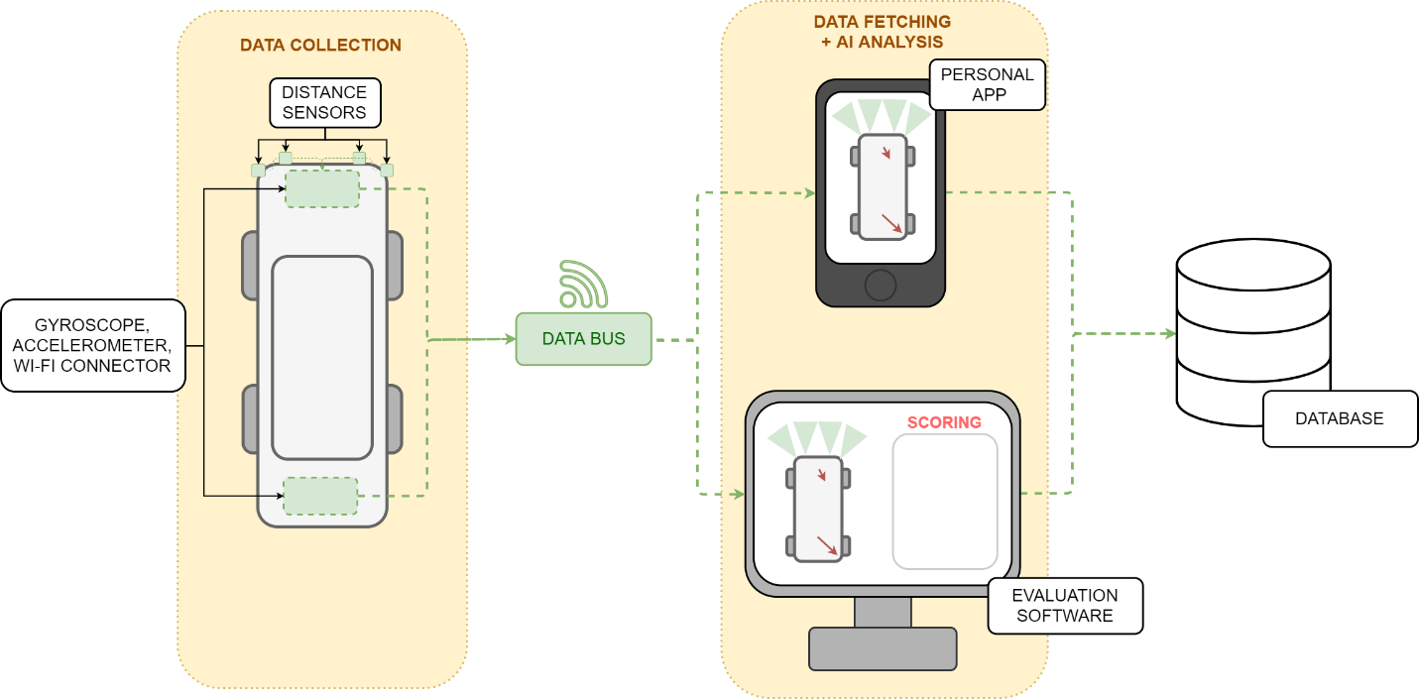

Think about the following questions, when writing this section:

* Does the project make effective and appropriate use of the major features of its chosen platform(s)?
* Were there significant platform features or even platforms the project could have benefitted from but failed to utilize?
* Does the project include innovations in technical design and/or implementation?
* Does the project include innovations in user experience?
* Does the project have a professional degree of production in terms of performance, user interface, visuals, and audio?

## Core Technologies

This includes your key platform(s) as well as specific technologies such as the Kinect SDK, the Unity game engine, or other elements that you believe will be critical to your project’s success.

# The Business Plan:

You don’t need to have a fully fleshed out business plan, we just want to know that you’ve put time into thinking about it.

## Competition:

What products, companies, or services will you directly compete with for your audience? How do you expect to differentiate your project from your competitors?

Think about the following questions in this section:

* Does the project create a new category of product or service?
* Does the project clearly and meaningfully innovate beyond existing products or services?

## Business Model

How will your project make money? If it provides an ongoing service, how will that service be sustainable? If there are critical partnerships you must make for your business model to work, describe those here as well.

Think about the following questions in this section:

* Does the team have a credible plan for getting their project to market in terms of business model, any required partnerships, or other factors?
* Does the project have a reasonable chance of success in its appropriate market given the team’s existing plan?

# Additional Information:

Add any links or information here. Any information you want to share is welcomed!